Natural Language Processing

Sentiment Analysis

NLTK Vader

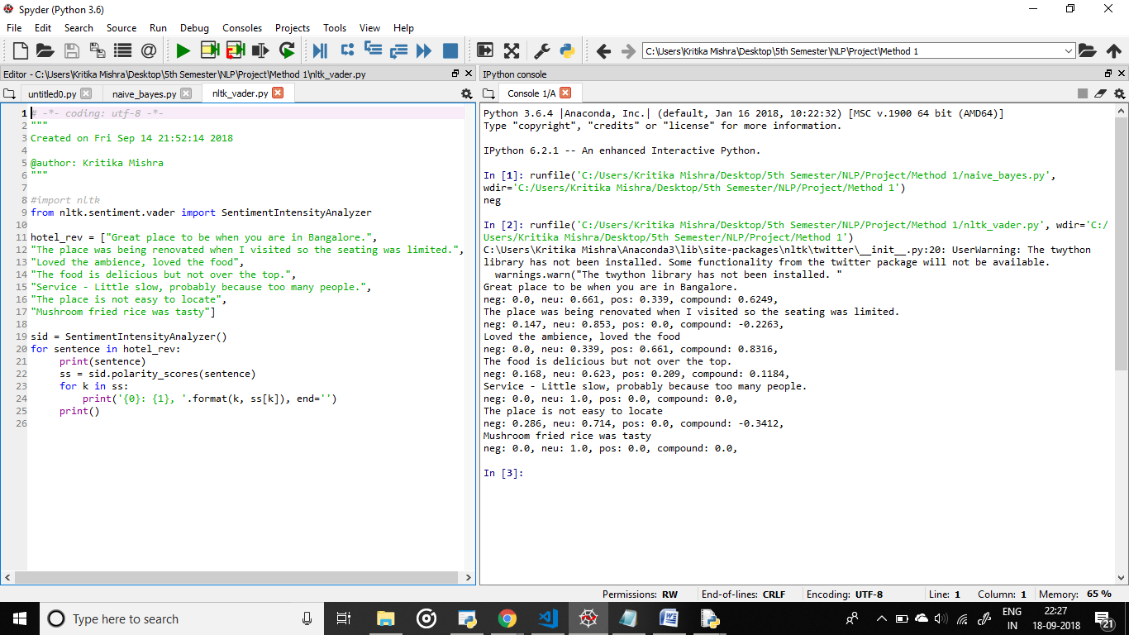

Naive Bayes Algorithm

